

**School of Computing**

**SRM IST, Kattankulathur – 603 203**

**Course Code: 18CSC206J**

**Course Name: Software Engineering and Project Management**

|  |  |
| --- | --- |
| **Experiment No** | 9 |
| **Title of Experiment** | Design a Sequence and Collaboration Diagram |
| **Name of the candidate** | Dhruv Deshmukh |
| **Team Members** | Papai Mondal (RA2111028010116)  Atharva Sohani (RA2111028010105) |
| **Register Number** | RA2111028010125 |
| **Date of Experiment** | 12/04/23 |

**Mark Split Up**

|  |  |  |  |
| --- | --- | --- | --- |
| **S. No** | **Description** | **Maximum Mark** | **Mark Obtained** |
| 1 | Exercise | 5 |  |
| 2 | Viva | 5 |  |
| **Total** | | **10** |  |

**Staff Signature with date**

**Aim**

To create the sequence and collaboration diagram for the OTT Recommendation System.

**Team Members:**

|  |  |  |  |
| --- | --- | --- | --- |
| **S No** | **Register No** | **Name** | **Role** |
| **1** | **Dhruv Deshmukh** | **RA2111028010125** | **Rep/Member** |
| **2** | **Papai Mondal** | **RA2111028010116** | **Member** |
| **3** | **Atharva Sohani** | **RA2111028010105** | **Member** |

**Sequence Diagram for the OTT Recommender system.**

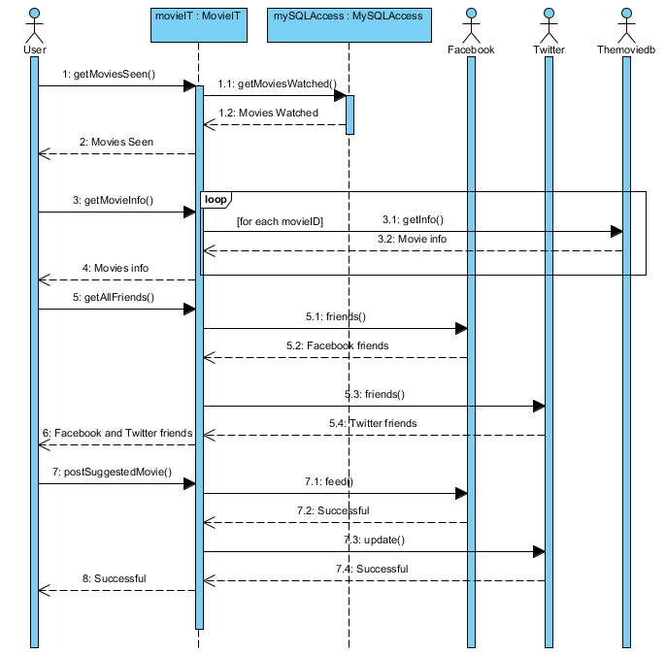

**Collaboration diagram for the OTT Recommender System.**

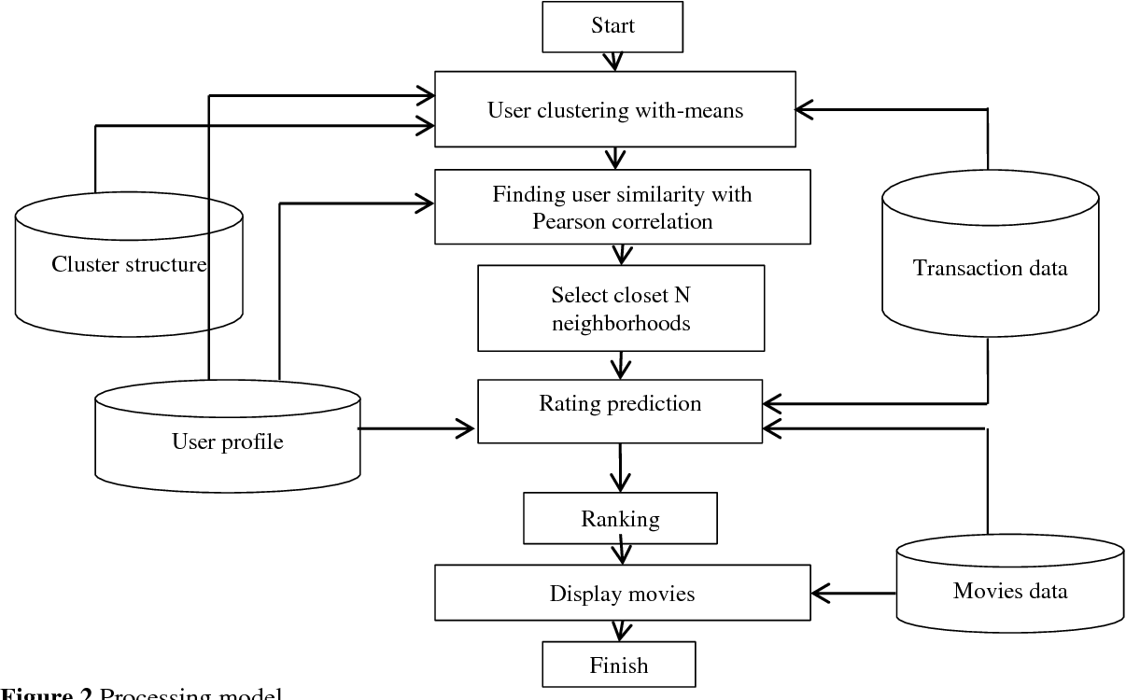

**\*/ For Example**

**Sequence Diagram**

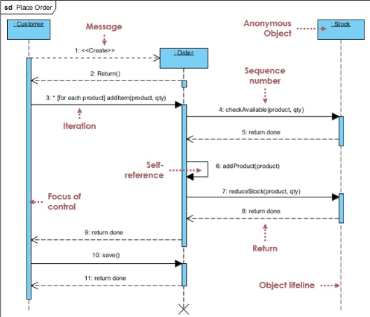

**Collaboration Diagram**

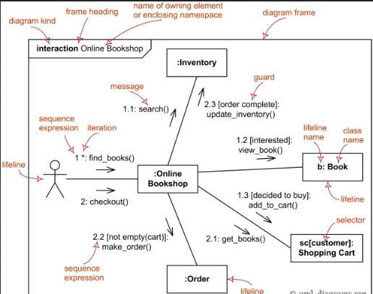

**Result:**

Thus, the sequence and collaboration diagrams were created for the OTT Recommendation System.